Project Report: Car Light Controller

INDIAN INSTITUTE OF TECHNOLOGY DELHI

Submitted by: -

**Jay K Modi** – **2016CS10356.**

**Utkarsh Singh** – **2015ME10686.**

**Objective**: - To design a sequential interior car light controller by the use FSM implementation.

**About the Device: -**

The light inside the car is controlled through various modes. Usually, there is a 3-way switch with the three positions labelled as SW_OFF, SW_DOOR and SW_ON, as shown in the picture. When this switch is in SW_DOOR position, the light is off only when all doors are closed. Opening any door(s) turns the light on. When the switch is in SW_ON or SW_OFF position, the light is on or off, respectively, independent of the status of the doors.

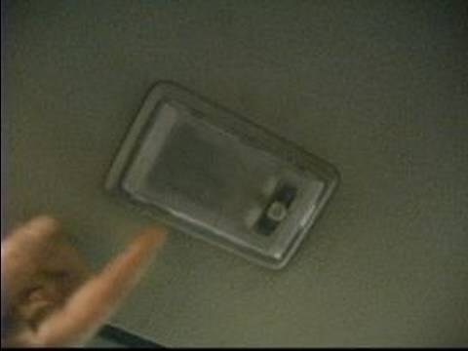

Now, when the switch is in SW_DOOR mode, the interior lights depend on the state of car, like whether doors are open or close, ignition is on or off, main door key is in or out, and the idle condition of car.

**How to use:-**

The usage of the device is a direct and is described in this section. 9 slide switches, 1 push-buttons, 2 LED’s and the SSD of the FPGA board are used. The slide switches are used for taking input about the state of all the four doors, door key and ignition. Also, the 3-way main switch is implemented using 3 slide switches as shown in the figure below.

Pushbutton is used for pushbutton which determines the speed of clock used.

LED’s are used for displaying the interior light and validity of input.

First two SSD’s are used to count down the three seconds, used to implement gradual off of interior light. Last two SSD’s are used to count down the ten seconds, used to implement the check if

Also, note that for resetting the device to default mode, turn all three main switches to off position.

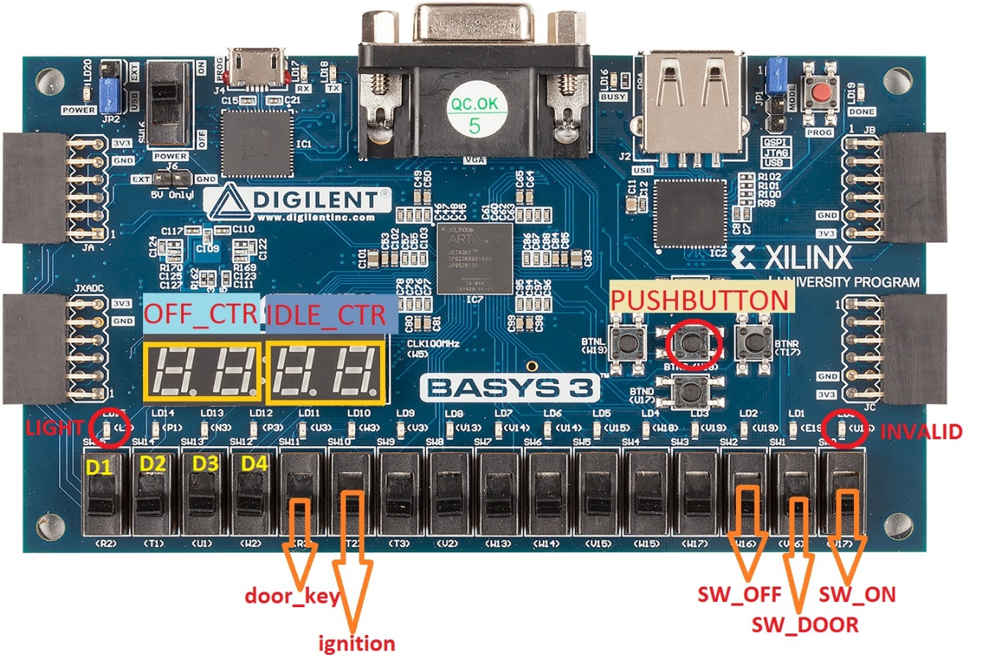

**Validation Methodology:**

Testing of the device is done using the board implementation of the design. Various test cases, both the basic and side, are used to confirm the correctness and effectiveness of the design.

Following table shows the various sequences inputs and corresponding outputs. The test cases include the basic cases and various sequences. Output in case is in accordance with the FSM.

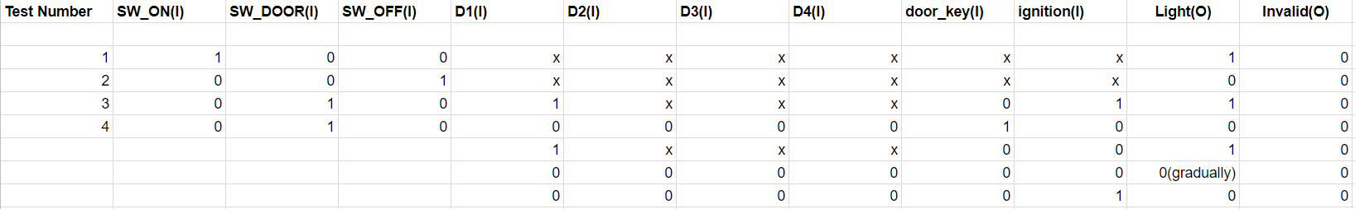

No other test bench is included in this report.